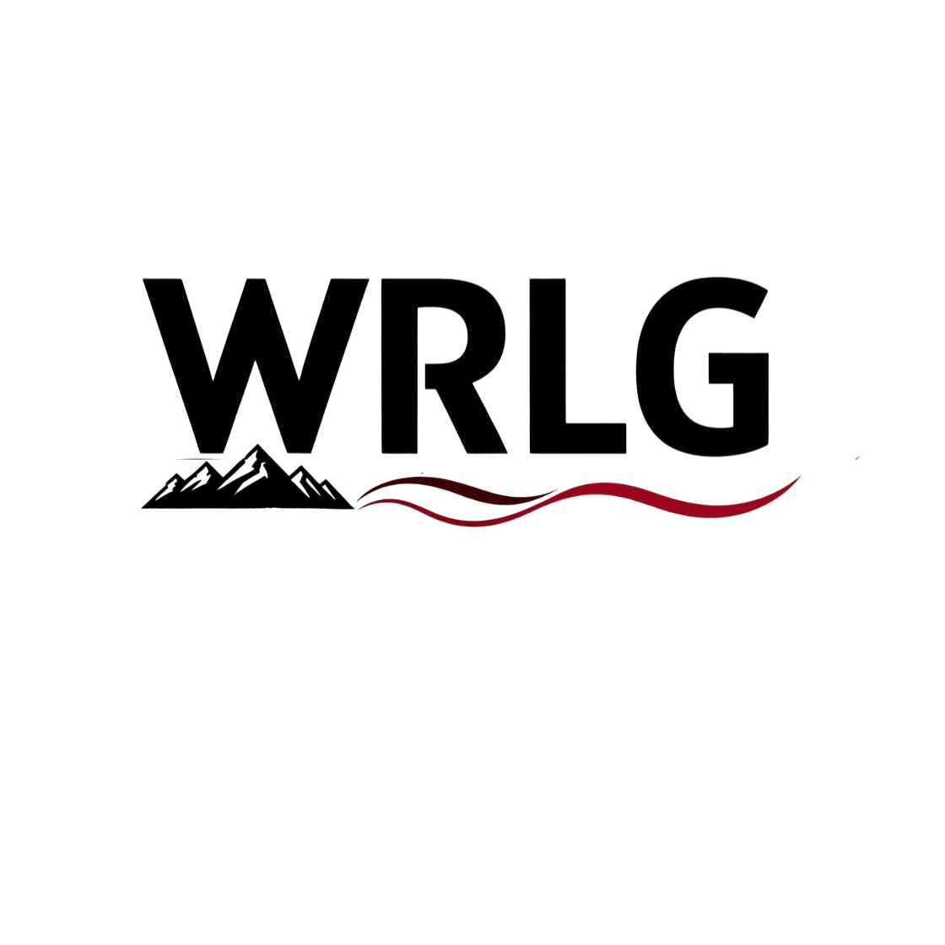
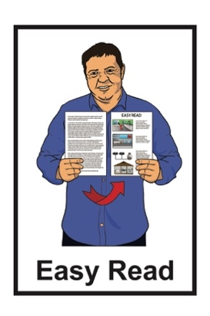

Waitaha Enabling Good Lives Regional Leadership Group (WRLG)

social media and website
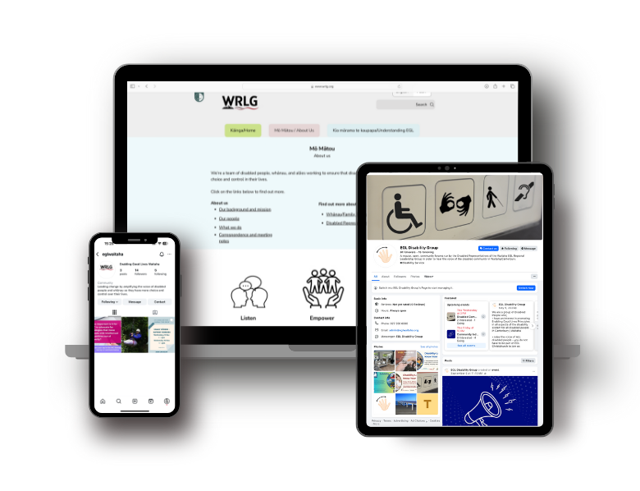

Published: September 2025

Our new website is live

The Waitaha Enabling Good Lives Regional Leadership Group has made a website.

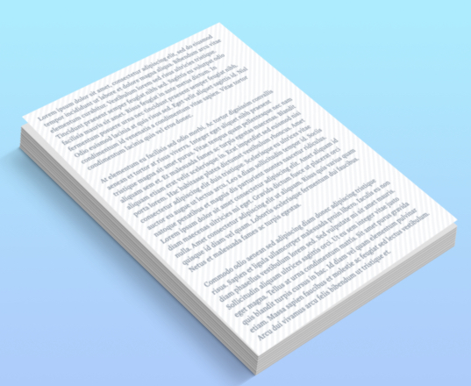
Waitaha Enabling Good Lives Regional Leadership Group is also called WRLG for short.

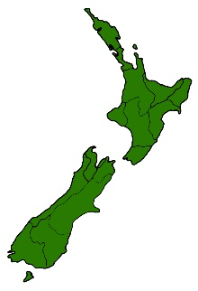
Here regional means an area of the country like Waitaha.

Waitaha is also called Canterbury.

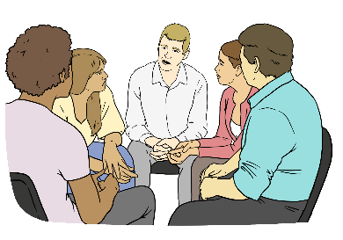
Here leadership means the group that:
leads change
and

the changes follow what Enabling Good Lives says.

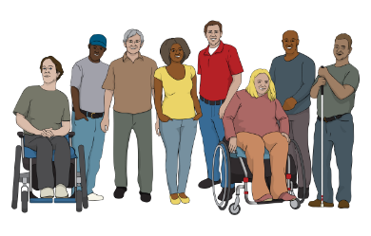
We are a team of:
disabled people
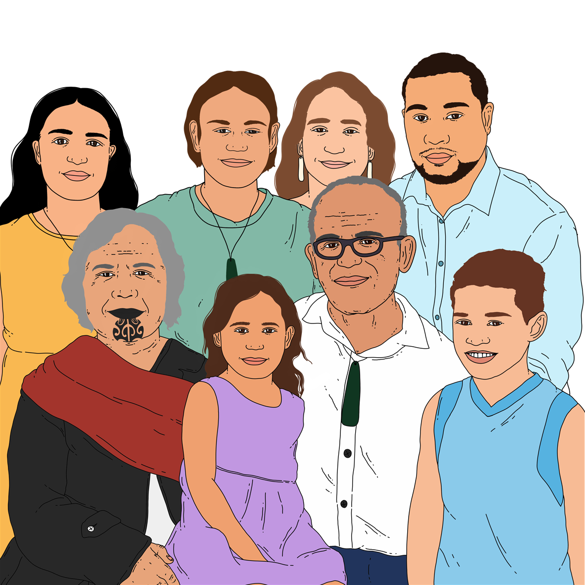
whānau / families of disabled people
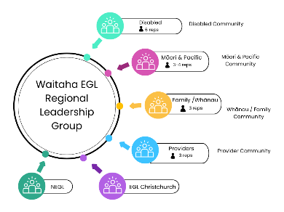
allies / supporters of disabled people
providers of services to disabled people.

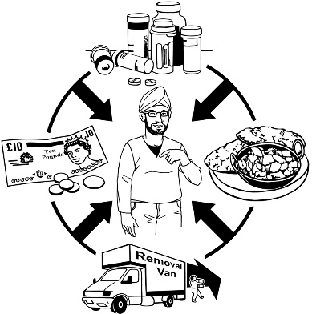
We are working towards disabled people and their whānau / families to have more:
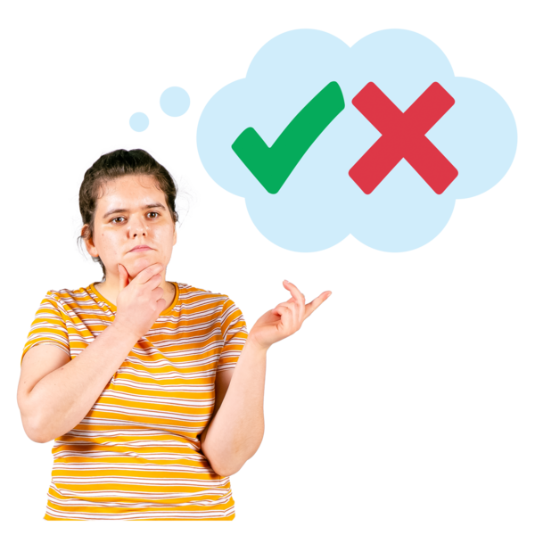
choice over their own lives
control over their own lives.

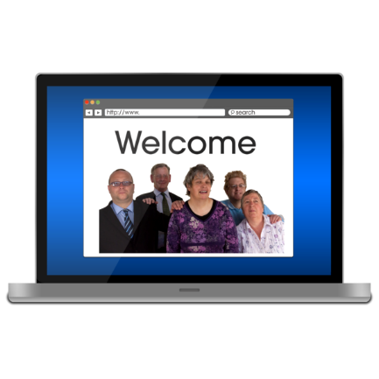
We would love for you to check out: our new website.

It is easy to use.

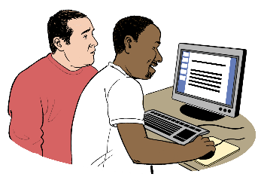
When you visit our website you will find out:
who we are
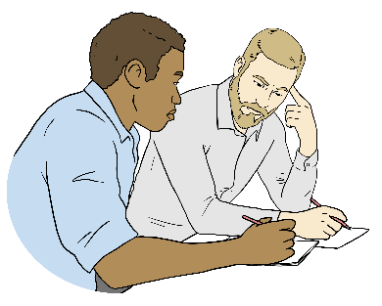
what we do
how we do it.


Find out more at our website:

https://www.wrlg.org


You can watch our video at this website:

https://www.wrlg.org

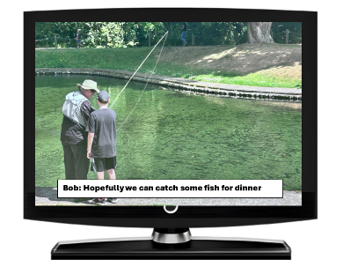
Our video:
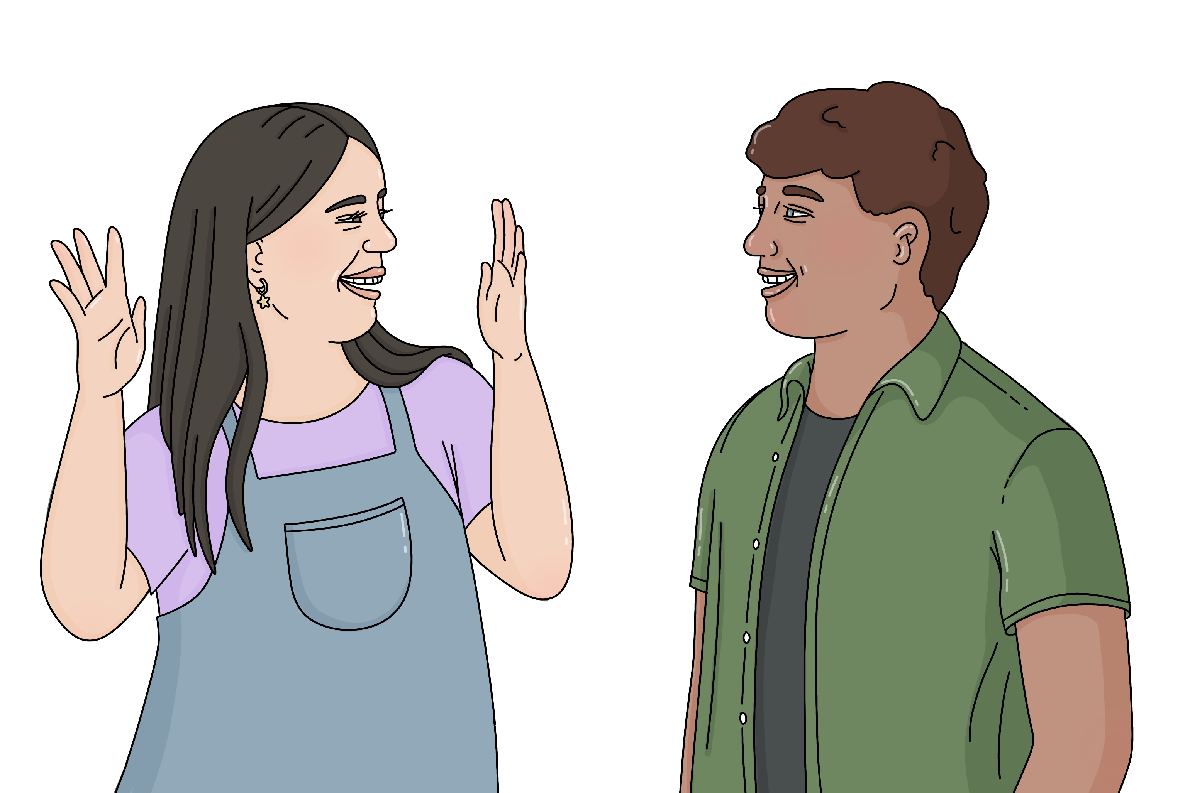
has captions which are words on the screen
is also in New Zealand
Sign Language.

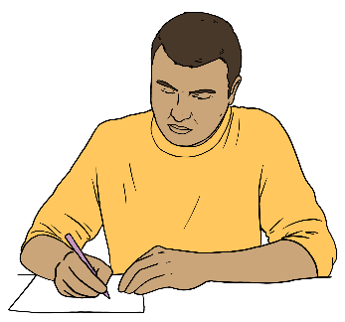
We have also written some of our information in:
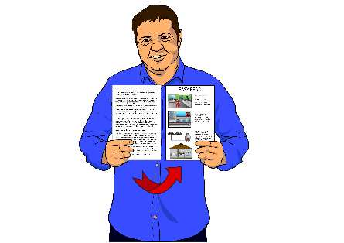
Easy Read
Plain Language.

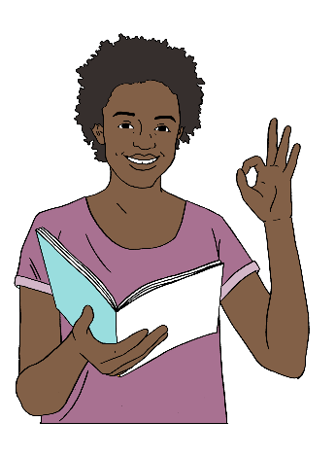
Plain Language is:
writing information in a way that more people understand
using words people know.
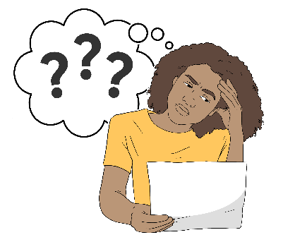


This supports more people to be able to understand our information.

You can also find us on:
Facebook at:
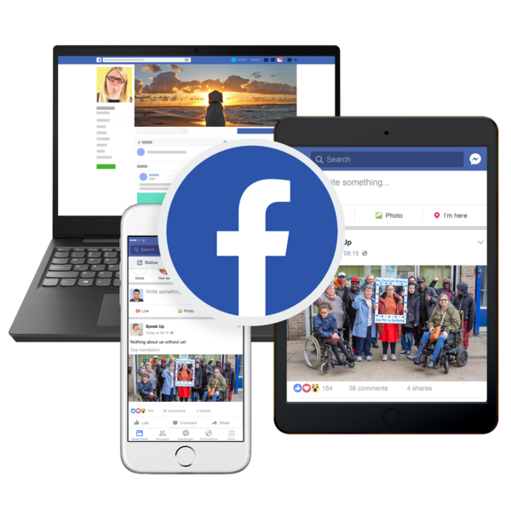
facebook.com/
disabilitygroupchch
and
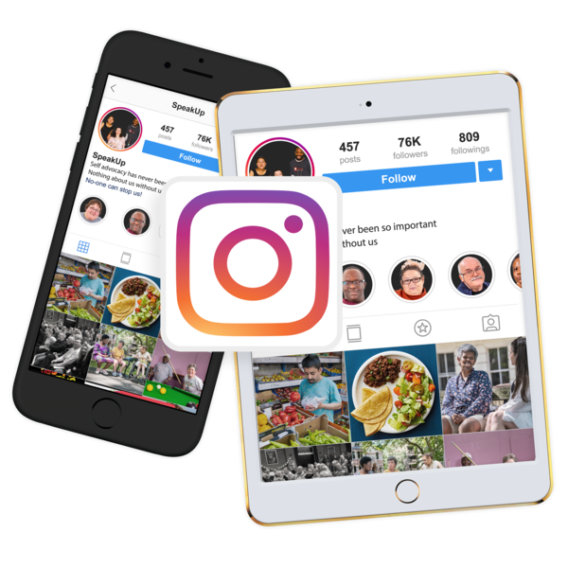
facebook.com/
disabilityfamilyconnections
Instagram at:
www.instagram.com/eglwaitaha
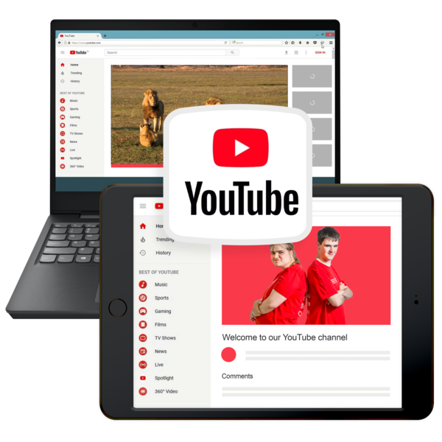
YouTube at:
www.youtube.com/@WRLG_EGL

This information has been written by the Waitaha Enabling Good Lives Regional Leadership Group.

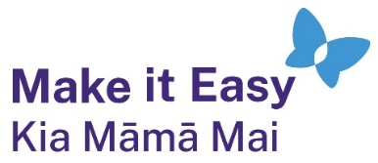
It has been translated into Easy Read by the Make it Easy Kia Māmā Mai service of People First New Zealand Ngā Tāngata Tuatahi.

The ideas in this document are not the ideas of People First New Zealand Ngā Tāngata Tuatahi.

All images used in this Easy Read document are subject to copyright rules and cannot be used without permission.


Make it Easy uses images from:

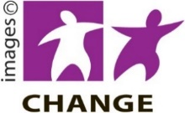
- Photosymbols

- Change Images


- Huriana Kopeke-Te Aho
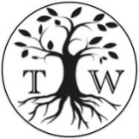
- SGC Image Works

- T Wood

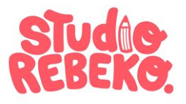
- Studio Rebeko

- Inga Kramer.

